**CONTACT FORM**

**Customer Information**

|  |  |
| --- | --- |
| First name |  |
| Last name |  |
| Address |  |
| Post code |  |
| City |  |
| Country |  |
| Email |  |
| Phone |  |

**Delivery Address (if different from above)**

Please be aware that deliveries are made during working hours from Monday to Friday and a signature may be required.

|  |  |
| --- | --- |
| Company and/or contact name |  |
| Address |  |
| Post code |  |
| City |  |
| Country |  |
| Phone |  |

**Purchase Information**

|  |  |
| --- | --- |
| Where was the item purchased (if known) |  |
| Original purchase price (if known) |  |
| Proof of purchase available (yes/no) |  |

**Return Item Details**

|  |  |
| --- | --- |
| Item description (size, color, style) |  |
| Reason for return |  |

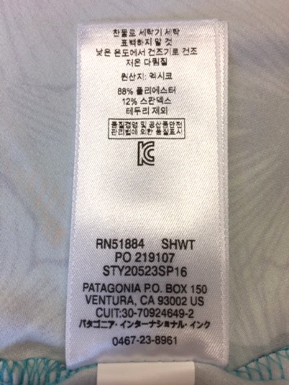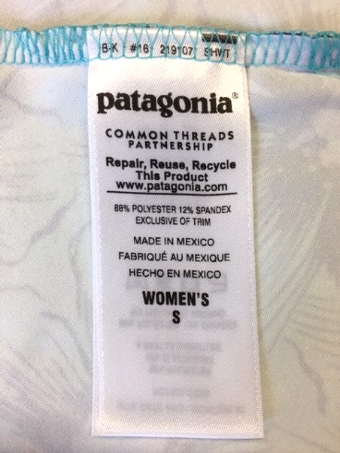

**Please also attach the following documents:**

* Clear pictures of the label front and back (see examples on the right)
* Pictures of the damage/defect
* Picture or scan of proof of purchase: (original invoice or receipt)

Patagonia Europe Coöperatief U.A. processes your personal data in order to provide you with repair services.  
For more information, check our [privacy notice](https://eu.patagonia.com/gb/en/privacy-notice.html).